

**METRO User Group: August 8 & 9, 2012**

**Metropolitan New York Library Council**

**57 East 11th Street #4, New York, NY (11am – 4pm)**

**Agenda for Attendees**

**10:30am-11:00am**: **Registration** **& Coffee**

**11:00am-11:45pm:**  **Meet, Greet**, **Overview** & **Goals**

**11:45am-12:00pm:** **Preview of** **ILLiad upgrades**

**12:00pm-12:30pm:** **Article Exchange & Intro to Addons**

**12:30pm-1:15pm:** **Lunch**

**1:15pm-2:15pm:** **Print Template Troubleshooting**

**2:15pm-2:30pm:** **Break**

**2:30pm-3:30pm:** **Roundtable discussions**

**3:30pm-4pm:** **Wrap up**

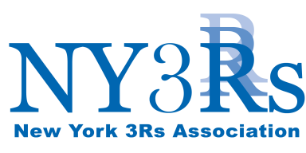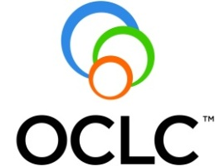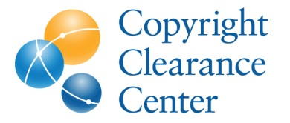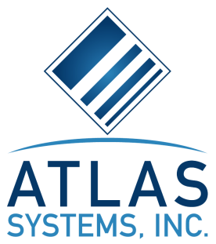

Made possible by our Strategic Partners